Expt.No.3: MOSFET Scaling Analysis and Subthreshold Swing Calculation using Nano Hub
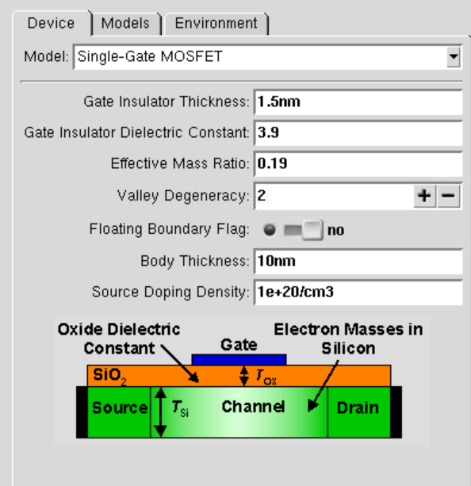
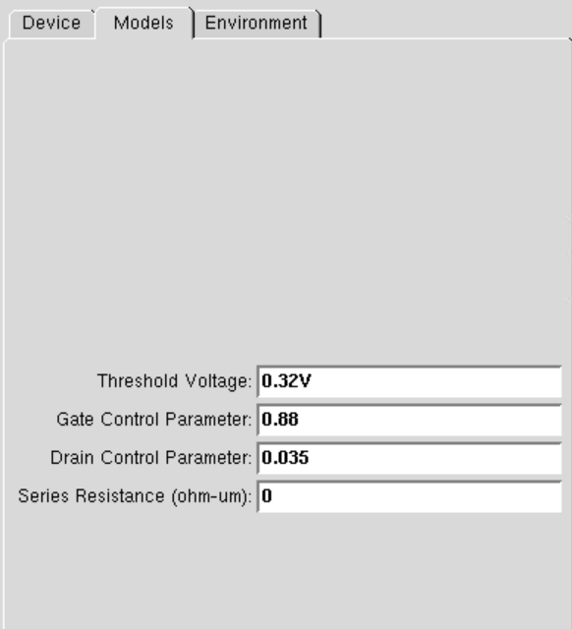
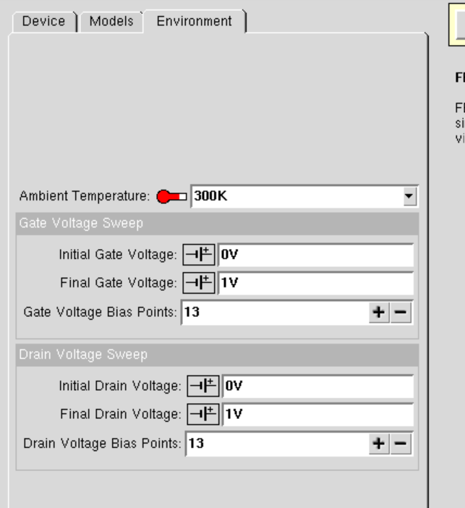
DrainCurrent vs. Gate Voltage plot
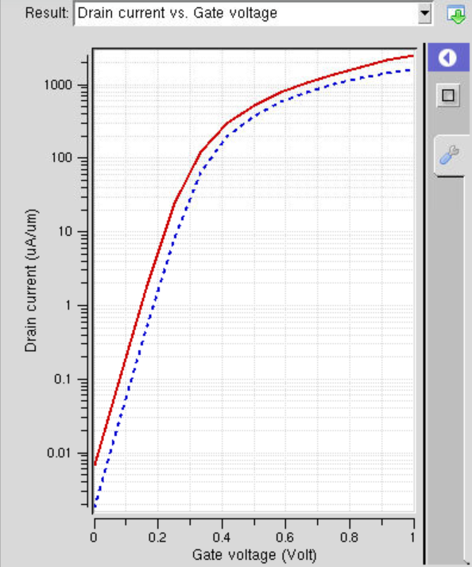
DrainCurrent vs. Drain Voltage plot
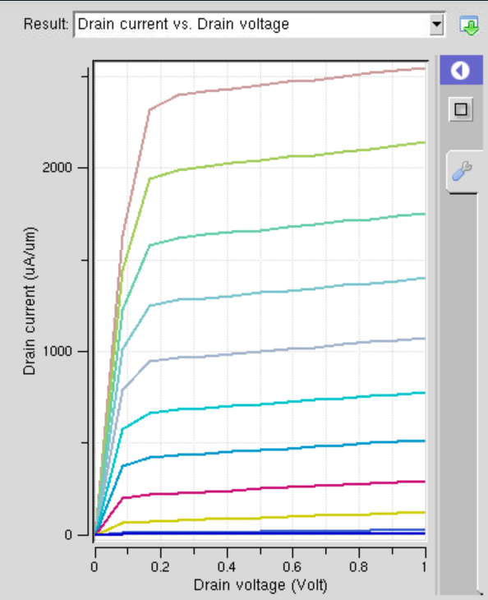

gm/Idvs. Gate Voltage plot
